CENTRALIZED VS. FEDERATED LEARNING
FOR TRAFFIC FORECASTING
A lightweight experimental study using the PEMS-BAY dataset
Team: Meghana P, Samitha Nayak, Radhika M H
Abstract
Traffic forecasting uses past traffic measurements to estimate future conditions. A centralized model learns from data collected in one place, while federated learning allows several clients to train locally and share model updates instead of pooling their training data. This project compares a centralized baseline with a federated learning simulator using the public PEMS-BAY traffic dataset. Federated experiments use three simulated clients and compare IID and non-IID data distributions with Federated Averaging (FedAvg). Performance is evaluated using MAE and RMSE, while training time, convergence, model size, and estimated communication traffic are also considered. Experiments across three random seeds are intended to test consistency. The system is a research prototype, not a live traffic-control deployment.

1. Introduction
Traffic conditions change over time, and reliable forecasts can help traffic operators understand likely changes in road flow. Machine learning can learn patterns from historical sensor data and use them to predict future observations. However, collecting data from different locations into one central system may be difficult because of data ownership, network limits, and operational constraints.
Federated learning offers another approach: each client trains on its own data, then sends model updates to a server that combines them. The raw training partitions remain at the clients in this simulated workflow. This project compares centralized training with federated training and studies how IID (Data is randomly distributed across clients with similar data distributions ) and non-IID (Clients receive data with different distributions, representing varying traffic patterns across sensors ) client data affect prediction quality and training behaviour.

Workflow:

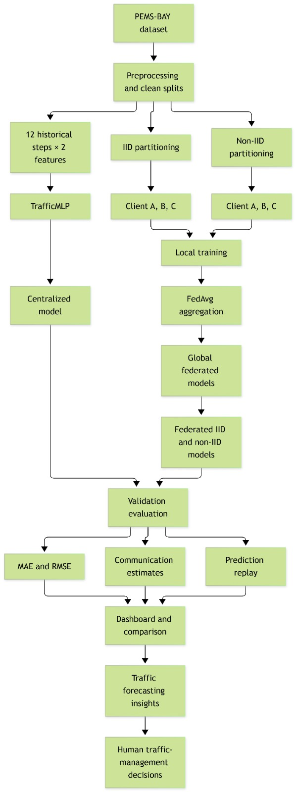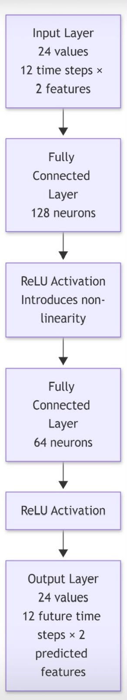

Fig 2. Architecture

Fig 1 represents the smart flow optimization process. This does …
- One public traffic dataset split across 3–5 simulated clients
The public PEMS-BAY traffic dataset is used to simulate three clients by partitioning the training data. Each client receives its own Parquet partition and trains locally. A partition manifest records the client identifiers, example counts, and assigned sensor IDs, making the partitioning process easier to inspect and reproduce.

- Implement FedAvg with one compact forecasting model
A compact multilayer perceptron called TrafficMLP with 13,016 trainable parameters is depicted in Fig 3. Each client trains a local model, and the server combines the client updates using Federated Averaging (FedAvg). The aggregation weights account for the number of training examples contributed by each client.
The server calculates a weighted average of those weights.
The mathematical formula is:

$w_{global}=\sum_{k=1}^{K}{}\frac{n_{k}}{\sum_{j}{}n_{j}}w_{k}$
Where:
- $w_{k}$ = model weights from client $k$.
- $n_{k}$ = number of training examples at client $k$.
- $K$ = total number of participating clients.
- $w_{global}$ = aggregated global model weights.

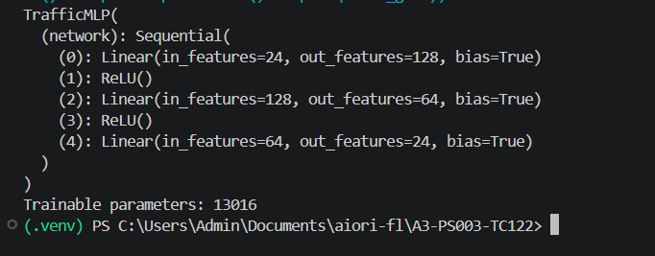
Fig 3.

3.Chronological train/test splits to avoid data leakage
Chronological order is preserved when splitting the traffic dataset. Because the forecasting horizon is 12 steps, or one hour, observations near the ends of the training and validation periods that could produce windows overlapping the next split are removed. This reduces the risk of information leakage between training, validation, and testing.
4. Compare IID and non-IID client distributions
Two client data distribution strategies are compared. In the IID setting, training examples are randomly distributed across clients. In the non-IID setting, complete sensor groups are assigned to individual clients, producing differences in the traffic data available to each client. We then evaluate whether the two distributions affect global-model convergence and prediction errors.
5.Measure MAE/RMSE, communication bytes per round, and convergence
MAE and RMSE are tracked after each federated communication round to evaluate prediction accuracy and convergence. Then, round duration and estimate communication traffic from the size of the model updates and the number of participating clients are also recorded. These measurements allow us to examine accuracy, convergence, and communication overhead together.
Estimates model-update traffic using a formula based on model size, the number of participating clients, and uploads plus downloads. This is an estimate of communication cost—not a measurement of actual network traffic.

MAE – Mean Absolute Error
MAE measures the average absolute difference between the predicted values and the actual values.

$MAE=\frac{1}{N}\sum_{i=1}^{N}{}|y_{i}-{\hat{y}}_{i}|$
Where:
- $y_{i}$ is the actual value.
- ${\hat{y}}_{i}$ is the predicted value.
- $N$ is the total number of evaluated values.
A lower MAE means the predictions are closer to the actual values on average.

RMSE – Root Mean Squared Error

$RMSE=\sqrt{\frac{1}{N}\sum_{i=1}^{N}{}(y_{i}-{\hat{y}}_{i})^{2}}$
RMSE gives more weight to larger prediction errors because it squares the differences before averaging.

Your code calculates estimated communication per round using:

$C=2×S×K$
Where:
- $S$ = model size in bytes.
- $K$ = number of participating clients.
- 2 = one download and one upload per client.
For your three clients:

$C=2×52,064×3$

$C=312,384bytesperround$
For five rounds:

$312,384×5=1,561,920bytes$
That's approximately 1.56 MB.
Your experiment's communication estimates

366.1 MB
Centralized raw training file

1.56 MB
Federated model exchange across five rounds

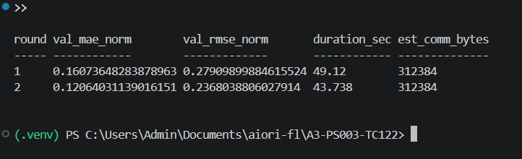
Round metrics for iid
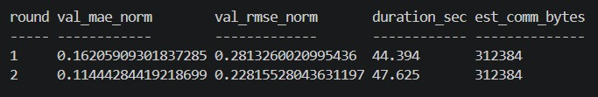
Round metrics for non iid
6.Run experiments using three random seeds
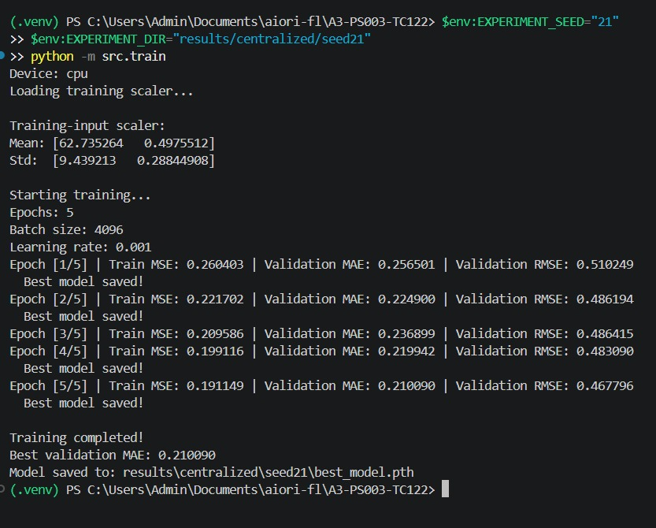
Seed 21
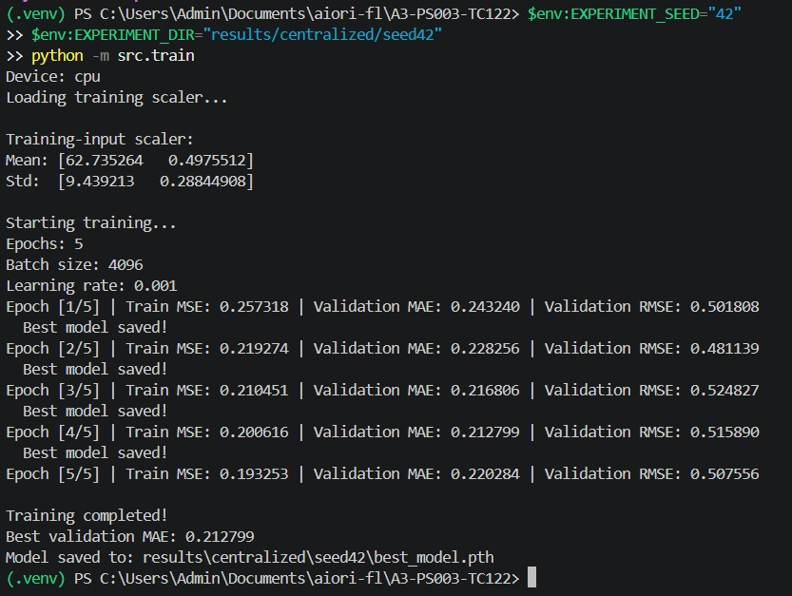
42
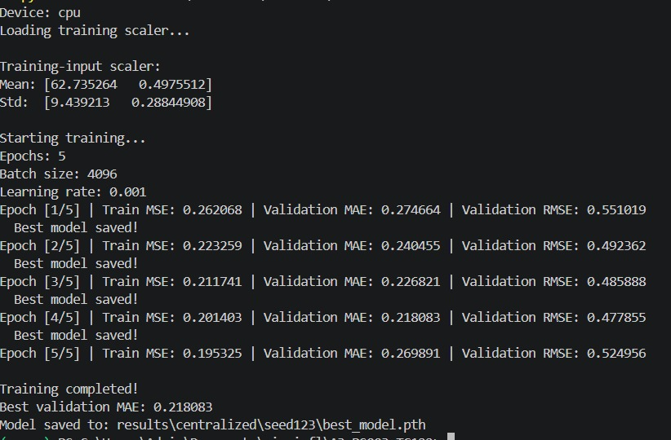
123
We use multiple random seeds to examine the consistency of the experimental results. The same seed values are applied to the relevant centralized and federated experiments, while the data splits and model configurations are kept consistent. Results across the three seeds can then be compared to distinguish repeatable patterns from outcomes that may depend on random initialization.
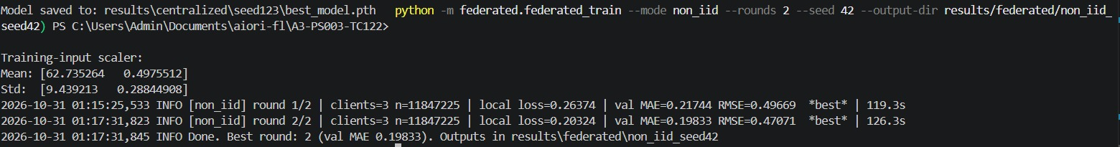
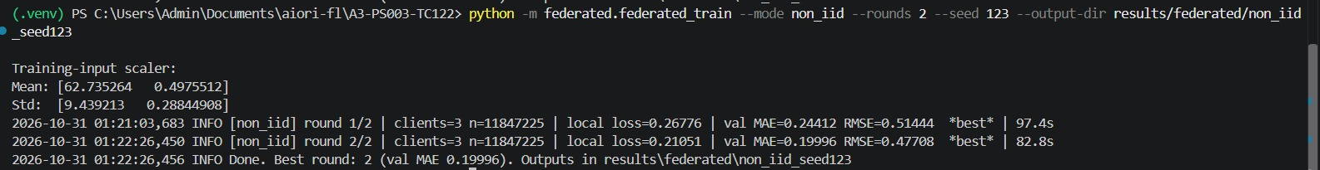
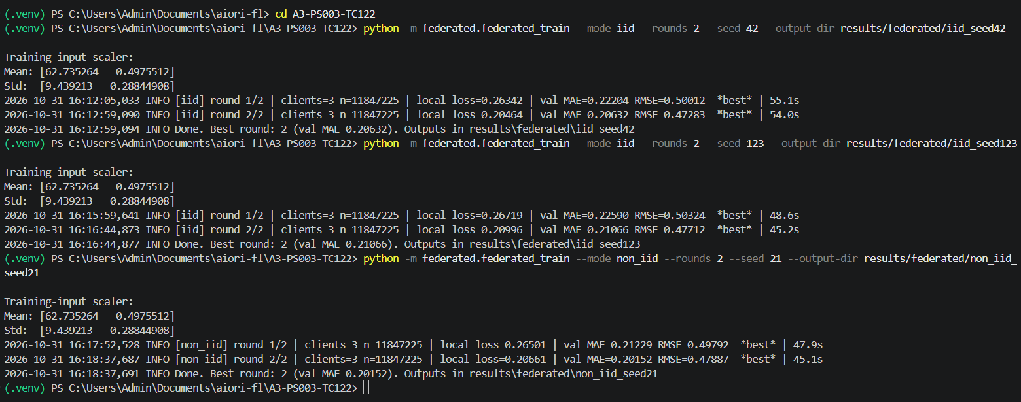

The project is a software-based federated learning simulator using an existing public traffic dataset. It does not use live cameras, deploy models across a city-wide traffic network, or provide formal differential privacy or cryptographic privacy guarantees. Federated learning keeps the original training partitions local to each simulated client during the training workflow, but this alone does not establish a formal privacy guarantee.

Conclusion
We started with a large public traffic dataset, prepared it carefully, divided it among three simulated clients, implemented local training and FedAvg, and designed experiments to measure accuracy, convergence, and communication overhead under IID and non-IID data distributions.

Future Work
Traffic sensors installed at different locations can act as individual clients. Each client trains the model using its local traffic data and shares model updates with a central server instead of sending raw training data. The server combines these updates using Federated Averaging (FedAvg) to create a global model that predicts future traffic conditions.
Traffic authorities can use these predictions to identify congestion early, plan traffic flow, and make better traffic management decisions. Before real-world deployment, the system must be tested with live data and monitored carefully.
- Improve accuracy: Test better models and forecasting methods.
- Reduce communication costs: Send smaller model updates and reduce communication frequency.
- Test with real traffic: Integrate live sensor data and evaluate performance in different locations.
- Strengthen privacy and security: Explore secure aggregation and differential privacy.
- Improve reliability: Detect unusual traffic conditions and provide uncertainty estimates.
- Expand the system: Test with more clients and larger traffic networks
Safety note: The system should initially support traffic authorities with predictions rather than directly control traffic signals. Human supervision and extensive safety testing are essential before deployment. .

